Name | Starter | Main | Dessert | Special Requirements Including Allergies & Intolerances
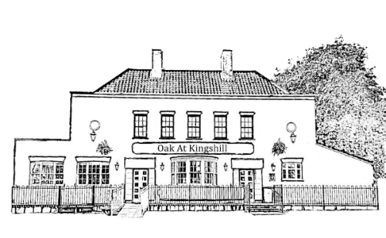
Oak At Kingshill Christmas Party Pre Order Document
Party Booking Name________________ Date Of Booking ________________ Number of People _______

