Name | Starter | Main | Dessert | Special Requirements Including Allergies & Intolerances
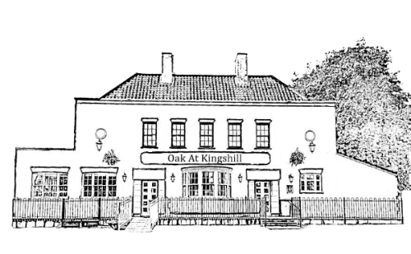
Oak At Kingshill Christmas Day Pre Order Document
Party Booking Name________________ Date Of Booking 25th December 2021 Number of People _______

